

**TNC Global**

**About us:**

TNC Global is a distributor of high quality products and services across many industries. We pride ourselves in serving our clients well, meeting their objectives, and delivering on time. Some of the sectors that we have worked with include:

Food Processing  
Engineering  
Hospitality  
Manufacturing  
Ports  
Pharmaceutical

We have extensive experience and technical expertise within these industries which has enabled us to build long term relationships with our customers, this has also enabled us to deliver the best solutions for them.  
Our success has grown from our ability to work closely with our clients to provide great customer service and quality leading brand products. We also take the time to get to know our customers and their business, so we can recommend efficiencies and cost saving measures to improve their business operations.

TNC Global started of as a small business and has expanded to a company employing highly skilled and dedicated individuals. TNC Global leadership and capabilities have helped to grow the business to where it is today.

**Our Experience:**

TNC Global provides high quality products across a range of industries to meet their operational needs. Our aim is to minimise any down time in your business so you can maximise your profitability. With TNC’s vision we have become the “go to” for any electrical, mechanical, hardware, tools, safety, or chemicals for your company requirements, our goal is to do this by providing 100% customer satisfaction.

With a growing base of customers which includes Hutchison Ports, we believe the high standards we are delivering to our clients are enabling us to become a trusted and reputable partner for any business.

**Our Fundamental Approach:**

Our approach is to provide professional, high-quality services to meet our clients’ needs and exceed their expectations, while effectively managing costs. We are successfully achieving our goal through our approach, we improve the quality of life of our clients and their businesses which is our mission. We are constantly evolving in order to become more flexible in our operations, more creative in our commercial offerings, more sustainable in our use of resources, more innovative in conducting our global business, and more efficient in our capital allocation.

**Our commitment:**

Here at TNC Global we strive to be the leader in the services and products we provide, and train our staff to deliver a superior service over our competitors. To do this we commit to provide our customers with products that meet or exceed their expectations for that we have established a Quality Management system in line with approved and accredited providers across our business.

Our aim is to have a positive impact on our customer’s time and resources and contribute to their overall business success. We do this through process optimisation, resource efficiency and innovations. We constantly proactively look for solutions for our clients that will help rationalise their costs and maximise their profits.

**What we do for our customers:**

Our customers deal with important challenges daily - we help them succeed by delivering quality products, innovative solutions, and great customer service.

We strive to create value for our customers by focusing on more vertically integrated building solutions rather than separate products. We invest time in our relationships, listening closely to understand our customers' needs, and then provide superior building materials and innovative solutions tailored to their specific construction needs.

**Innovation:**

We recognize that the global industrial concept is shifting toward more cost-effective, efficient, and environmentally friendly solutions; this inspires us to be more innovative in conducting our global business. We have considerable experience expertise in the areas defined below

**Operational Efficiency:**

Our business-best processes allow us to satisfy the needs of our customers while using the optimal amount of resources, thus creating the most value. We constantly seek to improve our performance as an efficient, agile, and innovative company by identifying, sharing, and implementing best practices across our global network of plants and facilities.

TNC Global is capable of supplying products in a timely, efficient and flexible manner to meet the needs of our customers. This requires us to be in regular contact with our customers and be ready to modify deliveries and products if the client needs should change.

We constantly create and develop methodologies that serve as the framework for our daily tasks.

**What we do:**

TNC Global is specialised in supplying products and meeting demand of various industries such as:

**Red Meat | Small Goods | Seafood | Poultry | Hatcheries | Piggeries:**

Hygiene and food safety is critical to food processing to ensure that food products are fit for human consumption and free from contaminants that could cause risk to human health due to microorganisms, including bacteria, viruses, parasites and moulds, toxins or agricultural chemicals Food hygiene can also help prevent food spoilage and protects against wastage and loss for food producers.

TNC Global has a wide range of hygiene products that can help your business increase the safety, control and eliminate any risks associated. Our product range is listed below:

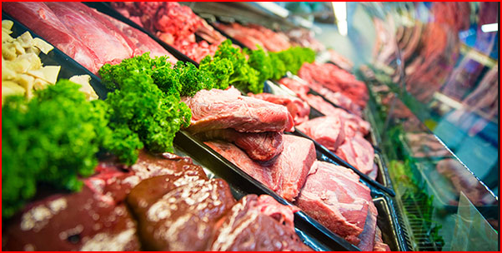

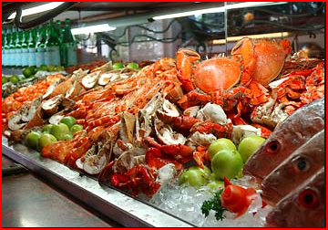

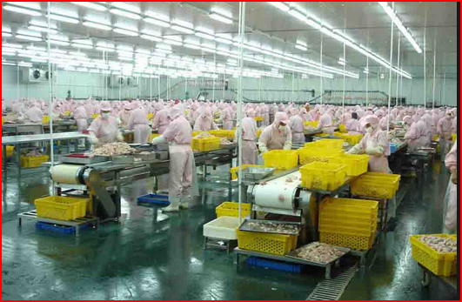

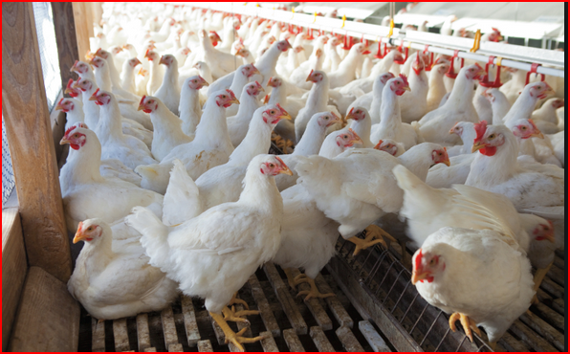

**Growers | Fresh Fruit and Vegetables (Industrial and Agricultural):**

There has been an increase in the number of outbreaks of illness associated with the consumption of fresh produce. Raising concerns about the potential safety of fresh fruits and vegetables to human consumption. This is due to an increased risk of biological hazards (microorganisms)

TNC Global can supply hygiene products that can reduce, control and eliminate the risk of potential hazards. Some of products ranges that can help and facilitate business for their health and safety requirement are listed in our products category.



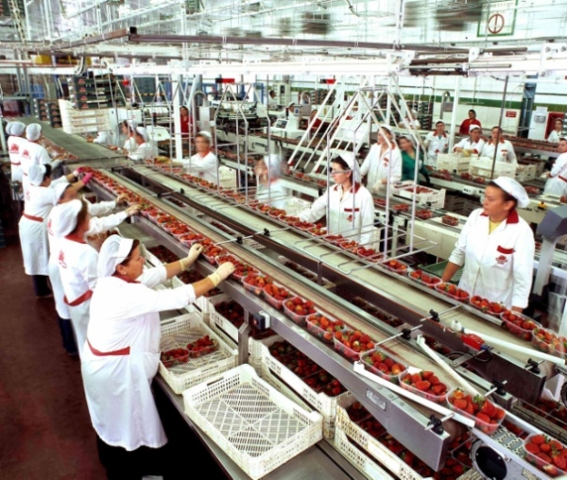

**Hospitality Industry | Cheese and Dairy Industry:**

We understand that within any hospitality environment 100% cleanliness is an essential part of your business. You are required by law to meet and maintain stringent standards to ensure the wellbeing of your customers and staff. The expense of not meeting the standards can be huge, from the cost of sick customers and staff, your businesses reputation, penalty notices and fines, as well as wasted food.

TNC Global provides your business with the following to guarantee you meet the legal requirements.

Cleaning products for food preparation areas, disposal areas, cleaning areas and floors, Washroom products to minimise the risk of harm or illness to any person, whether a customer consuming food, or a staff member processing.

[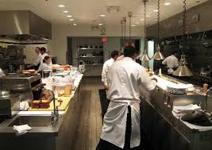](http://www.google.com.au/url?sa=i&rct=j&q=&esrc=s&source=images&cd=&cad=rja&uact=8&ved=0CAcQjRw&url=http://mickeysrun.com/busy-kitchen-design-decor-3-decorating-ideas.html&ei=SRceVZ_gMMawmAXc5oCoAQ&bvm=bv.89947451,d.dGY&psig=AFQjCNG9BnjCU1eB-IznkrwFd7bNELalWQ&ust=1428121773502917)



**Food Services | Food Manufacturing and processing:**

With clients ranging from companies and food processors and manufacturer that provide airline flight meals to organisations who distribute food to the catering industry, this is a key area of our business. We provide cleaning and hygiene products, food grade packaging, foam and film products.

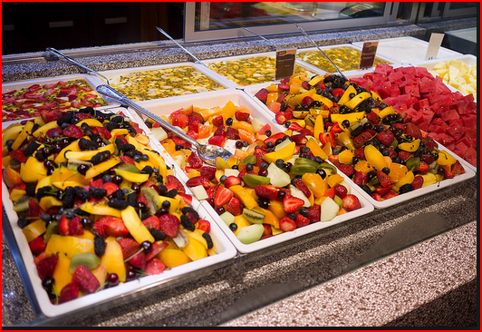

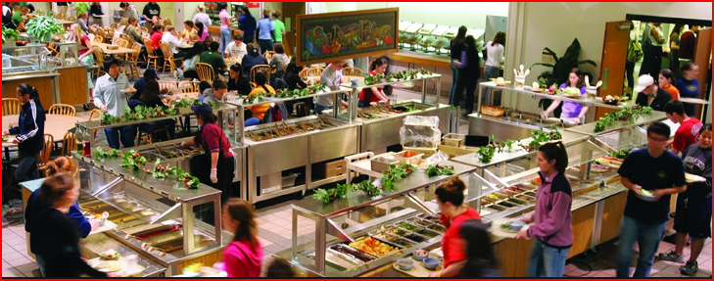

**Pharmaceutical industry:**

Here at TNC Global we supply fine and specialty hygiene and safety product such as Packaging, PPE and materials handling equipment and consumables which we source from well reputed manufacturer. We are governed by the guiding principles of innovation, resourcefulness, proactiveness and accuracy.

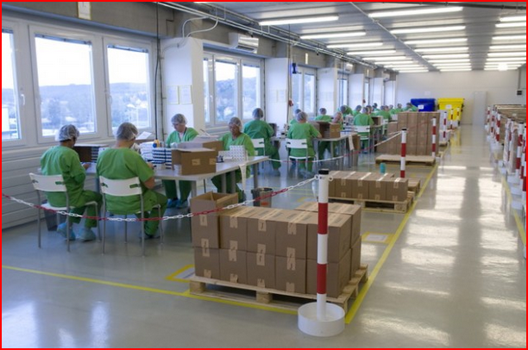

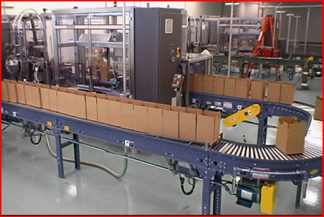

**Packaging:**

When determining what material works best for specific food applications we do analysis to understand the factors such as polymer characteristics and chemical interaction with products and consider the condition in which the product will be kept such as humidity and temperature to come up with the most suitable packaging type for our customers.

We can also source and provide biodegradable and eco friendly products as well as the primary and secondary packaging, foam and film for any of the above areas of food production. I.e. Meat, dairy, confectionary, etc

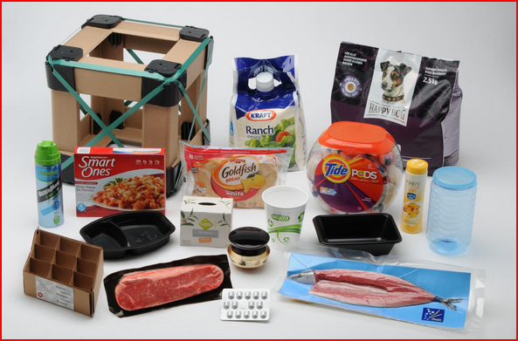

** **

**#4e4e4e**

|  |  |  |  |
| --- | --- | --- | --- |
| **Our Products Categories and Range** | | |  |
| **Chemicals** | **Safety equipment and Services** | **Oil filtration** | **Hardware** |
| Washroom supplies and accessories | automotive material handling equipment and machineries | Industrial liquids | Hand Tools |
| Cleaning Chemicals | Pest Management | Filtration products | Electrical tools |
| Equipment Cleaning |  | Hydraulics | Hydraulic tools |
|  |  |  | Air tools |
|  |  |  |  |
| **Electrical** | **Consumables** | **Packaging** | **Fabrication** |
| Data Communication | PPE | Foam and Films | As per Specifications |
| Lighting | Clinical Protective Equipment | Food Grade Packaging |  |
| Ventilation | Disposables | Corrugated Packaging |  |
| Test Measurements | First Aid Kits & | Biodegradable |  |
| Switch Gears | Accessories | Primary and Secondary packaging |  |
| Electric Cables | Personal Hygiene |  |  |
| Electrical Accessories |  |  |  |

**Our People**

TNC Global takes pride in the team of professionals we have on board to service your business. The team’s experience covers a range of industries from food and beverages to engineering, Ports and manufacturing giving them an inherent advantage in understanding their particular business needs.

With the extensive experience and knowledge we have while working in industry our team’s achievements include:

Overseeing a company’s sales growth from number 7 to number 3 in market share

- Increased market share to 73%

- Designing and implementing a VDP (value deliver program) for key accounts

- Responsibility for strategy and roll out of all global technical innovations

- Doubled revenue for an energy systems company over an eight year period

As a result our team has a deep seated commitment to help you develop your business. Our people strive on a daily basis to go over and above your expectations in order to deliver truly great results. This ethos is borne out in the feedback we get from our satisfied customers.

**Customer Service**

We are confident that we deliver superior products and services with excellent customer service to our clients. We are committed to ensure our customer satisfaction rates continue to increase through the development of our products and services and the commitment of our staff to actively participate in all quality related activities.

**Competitive Pricing**

We know the cost of our products and materials will have a major impact on your cost competitiveness; we therefore offer goods at highly competitive prices and look for ways to constantly reduce the cost to your customers.

**Policy**

TNC maintains an effective and efficient Quality Management System (QMS) based on our strict first class GMP principles within our business units. We provide HACCP and ISO Accredited and certified products and services which meet Australian standards and FDA approvals.

We value our customers and suppliers, and strive to maintain long term relationships.

We commit ourselves to the principles of the companies Code of Conduct. Every employee feels responsible to maintain high quality standards of our products and services.

Through continuous improvement and innovations we are able to reach our goals, in order to secure the economic success of our customers, suppliers and our company.

We believe in international and process-oriented teamwork and we respect and value cultural differences within our operations.

We commit ourselves to adhere to the all relevant legal rules, regulations and certification standards and this way guarantee superior quality and compliance of our products and services.

We protect know how, business and trade secrets and this way protect the long term success of our company and business partners.

We commit ourselves to handle resources in a careful, economic and efficient manner.

It is our business mission to accomplish the requirements and expectations of our stakeholders (customers, end users, suppliers and employees) in order to secure profitability and sustainability of the company. With the excellent fulfilment of our business requirements in terms of quality, environment, health and safety.

Our business mission is “Your Trust Our Ambition”

**Environmental Responsibility**

Here at TNC Global is committed to operating an environmentally-sustainable business and commit to comply with the environmental management system. We also promote a healthy and environmentally-friendly alternative to our clients.

Throughout our network, we continually look for ways to reduce total energy use and food miles and are implementing a variety of initiatives to reduce our environmental impact.

Our Procurement team also continues to implement packaging and products improvements to meet rising customer expectations for performance and safety, while also reducing waste, cost and our environmental footprint. Our “Guiding Principles for Environmentally Preferred Purchasing” ensure that sustainability-related factors are taken into consideration when buying decisions are made.